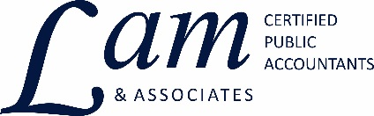

"One of the virtues of being very young is that you don’t
let the facts get in the way of your imagination."
-- Sam Levenson, humorist

Tax Tip – January 18, 2017

Children & Dependents

If you claim a person as a dependent, no one else, not even that person, can claim the exemption. You cannot take an exemption for anyone with 2016 income (excluding Social Security and tax-exempt income) over $4,050 except your spouse or a child under age 19 (under 24 if a full-time student).

There is a uniform definition of “qualifying child” for HH filing status, the child care credit, and the earned income credit (EIC).

Whether or not a dependent child needs to file a tax return depends on several factors-how much income and what type of income (earned, unearned or a combination) the child has. A return must be filed if:

- The child’s earned income from a job exceeds the Standard Deduction -$6,300 in 2016;
- The child’s unearned income (interest, dividends, investment income) exceeds $1,050; or
- The child’s gross income (the combined earned and unearned income) exceeds the larger of $1,050 or the child’s earned income (up to $5,950) plus $350.

You can report and pay a child’s tax on your return if you and the child meet certain requirements.

If you have any questions regarding this information, please feel free to contact our office.

P.S. Please forward this to your friends or colleagues that you'd like to introduce our firm to. Or send us their email address and we'll ask for their permission to forward with your compliments.

Contact Info:
Lam & Associates
437 Dotts Street
Pennsburg, PA 18073
(215)679-6221 Fax: (215)679-6233
info@hlkulp.com www.hlkulp.com

If you would like to be removed from our mailing list, please email us at info@hlkulp.com

